Tack n’ Treasure
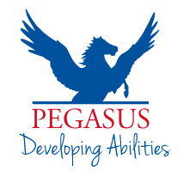
Get “tacky” with us

On Saturday, October 28, Pegasus is holding a ‘Tack n' Treasure’ sale to raise funds to purchase specific tack and related aids for our riders with a disability.

So if you have any unwanted – but still in good nick – tack, we want to hear from you! Any donations gratefully received, and a huge thanks in advance!

Desired items include:
- saddles
- stirrups, bridles, halters, reins, bits, and harnesses
- martingales and breastplates
- boots and jodhpurs
- jackets, rugs and saddle blankets
- any other horse-related item which fits the category.

Donation items can be dropped off to us at Pegasus Farm – 119 Drake Brockman Drive, Holt – between now and Saturday, October 28, 2017. We are open Monday to Friday between 9am and 5pm. (If delivery is difficult, please call Pegasus on 02 6254 8790 to arrange an alternative option).

100% of all proceeds will be used to purchase equipment for Pegasus’ program participants.

Need more information?
Contact us on 02 6254 9190 or email volunteers@pegasusact.com.au

Thank you - Pegasus greatly values your contribution

